Overview of the

Risk Prediction Index (RPI)v3

This document will provide an overview of how the Risk Prediction Index (RPI) assessment, Version Three, will function, and how it is intended to integrate with PRISM.

Furthermore, this document provides the methodology of calculating RPI Version Three assessments. There will be some subtle differences in operation between RPI assessment tools. Where there may be any confusion, the prior version will be referred to as AIFP RPI whilst the new version will be referred to as PRISM RPI.

The calculations and preparation for RPIv2 was completed and will be released in Jan 2020. RPI v3 is in development and presume to launch approx. late 2023.

This document should be used in conjunction with RPI Technical Manual July 2018, that contains further information on the overall RPI Assessment process.

Contents

Purpose of RPI 4

Factors and Scales 4

TABLE A 4

Question Method 8

Opinion Method 8

Biodata Method 8

Preference Method 8

Question Types 8

Background Questions 8

Standard coded questions 8

Reverse coded questions 8

Consistent Responding questions 8

Assessments 9

Scoring of the Assessments 10

Raw Score 10

Critical Score / Critical Mode 10

Potentially Revealing items 10

Applicant Score – applicable for RPI V3 due for release July 2021 10

Z Score 11

STEN (Standard TEN) Score 11

Scale Validity and Substitution Rule do not apply 11

Revelian Cognify Score 11

Revelian Emotify Score 11

SAFE Assessment 11

SAFE Question Type and Method 11

All SAFE v2 Questions 12

SAFE Scales 12

Table of SAFE Scales 13

SAFE Scales Scoring procedure 13

SAFE Ordinary Scales 13

SAFE Ordinary Scale / Applicant Score formula 14

SAFE Ordinary Scale types of scoring 14

SAFE Ordinary Scales STEN results 14

TABLE C 14

SAFE Ordinary Scale STEN formula 14

TABLE C1 15

SAFE Ordinary Scale types of scoring – Patch 15

SAFE Ordinary Scale STEN formula including Ordinary Scale Patch 16

Convert SAFE Ordinary Score to use in final RPI Score 16

SAFE Negative Scales 16

Consistency/ Careless Responding, Fake Good, Guardedness 17

Consistency / Careless Responding 17

Fake Good 18

Fake Good SAFE Ordinary Scale / Applicant Score formula 18

Fake Good result invalidates RPI Report 18

Guardedness 18

Guardedness Scale STEN formula 19

LOC - The Life Orientation Checklist Scoring Procedure: 19

Question Method and Type 19

All LOC v2 Questions 19

LOC Scoring of Assessment 20

LOC Scale STEN formula 20

TABLE E 20

Convert LOC Score to use in final RPI Score 21

TABLE F 21

OPA - Organisational Policy Assessment Scoring Procedure 21

OPA Question Method and Type 21

All OPA v2 Questions 22

OPA Scoring of Assessment 22

Convert OPA Score to use in final RPI Score 22

COS - The Community Opinion Survey Scoring Procedure: 22

All COS v2 Questions 22

COS Question Method and Type 23

COS Scoring of Assessment 23

COS Scale STEN formula 23

Convert COS Score to use in final RPI Score 24

Overall Emotional Intelligence 24

Overall Cognitive Ability 25

Overall RPI Score Calculation 26

Calculating the RI Score in Version 2 26

TABLE F 26

Norm Data 28

Jurisdictions 29

Reports generated for client 30

Test Event Summary Results page – AIFP Version 30

Comprehensive Report Format – AIFP RPI format 31

Test Event Summary Results page – PRISM version 32

33

Comprehensive Selection Report Format – PRISM RPI 33

Comprehensive Selection Report – Cover page 34

Comprehensive Selection Report – Candidate Background Information 34

Comprehensive Selection Report – Psychological Risk Overview 36

Psychological Risk Rating 36

Risk Prediction Score 36

Cognitive Ability Score 36

Recommendation 36

Statement under the Risk Rating 37

Prior Assessment Results 37

Assessment Validity 38

Selection Report – Risk Profile Interpretation pages 40

Selection Report – Supplementary Items for Interview 40

Selection Report – About this Report 43

Feedback Report – front page 44

Feedback Report – Interpretation pages 44

Client Experience 47

Candidate Experience 47

# Purpose of RPI

This behavioural assessment is designed to measure risk predominantly in the emergency services and public safety industries. It has been tailored to assess candidates in high risk roles where they may need to:

• Deal with heightened emotions

• Work with emotionally vulnerable people

• Use force

• Face the threat of violence

This assessment reports over 36 scales in 6 factors to determine suitability of candidates for a role.

# Factors and Scales

There are six domains and 36 Scales, and corresponding questions are prior constructed and vetted by Professor Martin Sellbom, in conjunction with our SafeSelect psychologists.

### TABLE A

|  |  |  |  |  |  |  |
| --- | --- | --- | --- | --- | --- | --- |
| Factor | Scale | Assessment | Item Count | Scale Direction | Adds to RPI score | RPI Weight |
| 1 - Approach to Testing | | |  |  |  |  |
|  | Fake Good | SAFE | 13 | negative | yes | 2 |
|  | Consistency/Careless Responding | SAFE | 18 pairs | negative | yes | 1 |
|  | Guardedness** | SAFE |  |  | no | NA |
| 2 - Ability to Learn and Understand (please see documentation on Cognify & Emotify) | | |  |  |  |  |
|  | Overall Cognitive ability | Cognify |  | other | no | NA |
|  | Problem Solving | Cognify |  | other | no | NA |
|  | Verbal Knowledge | Cognify |  | other | no | NA |
|  | Numerical Reasoning | Cognify |  | other | no | NA |
|  | Overall Emotional Intelligence* | Emotify |  | other | no | NA |
| 3.1 - Working with Others (Positive) | | |  |  |  |  |
|  | Accepts Responsibility | SAFE | 7 | positive | yes | 1 |
|  | Helps Others | SAFE | 10 | positive | no | NA |
|  | Self - Awareness | SAFE | 9 | positive | yes | 1 |
|  | Self Confidence | SAFE | 9 | positive | yes | 1 |
|  | Team Orientation | SAFE | 9 | positive | yes | 1 |
|  | Interpersonal Sensitivity | OPA | 50 | positive | no | NA |
|  | Punitive/Harshness – 9 questions, scored against OPA-Punitive/Harshness sub-scale | OPA | 9 | Positive | yes | 1 |
|  | Bluntness/Scepticism – 22 questions, scored against OPA- bluntness/Scepticism sub-scale | OPA | 22 | Positive | yes | 1 |
|  | Generosity/Kindness – 12 questions, scored against OPA- Generosity/Kindness sub-scale | OPA | 12 | Positive | yes | 1 |
|  | Integrity Behaviour | SAFE | 5 | negative | yes | 1 |
| 3.2 - Working with Others (Negative) | | |  |  |  |  |
|  | Arrogance | SAFE | 8 | negative | yes | 1 |
|  | Dominance | SAFE | 7 | negative | yes | 1 |
|  | Gender Bias | SAFE | 9 | negative | no | NA |
|  | Racial Bias | SAFE | 10 | negative | yes | 1 |
| 4 - Work Style | | |  |  |  |  |
|  | Conscientiousness | SAFE | 9 | positive | yes | 1 |
|  | Follows Rules | SAFE | 6 | positive | yes | 1 |
|  | Leadership Ambition | SAFE | 10 | positive | yes | 1 |
|  | Patience | SAFE | 9 | positive | yes | 1 |
|  | Persistence | SAFE | 10 | positive | yes | 1 |
|  | Attitudes towards Authority | SAFE | 9 | negative | yes | 1 |
|  | Attitude to Enforcing Rules | COS | 12 | other | yes | 1 |
| 5 - Psychological Adjustment | | |  |  |  |  |
|  | Anxiety | SAFE | 7 | negative | yes | 2 |
|  | Depression | SAFE | 8 | negative | yes | 2 |
|  | Emotional Vulnerability | SAFE | 10 | negative | yes | 1 |
|  | Mental Health Treatment | SAFE | 6 | negative | yes | 1 |
|  | Mistrust of Others  (was Paranoia) | SAFE | 10 | negative | yes | 2 |
|  | Unusual Beliefs and Experiences  (was Possible Psychosis) | SAFE | 7 | negative | yes | 2 |
|  | Antisocial Tendencies (was Psychopathic Tendencies) | SAFE | 9 | negative | yes | 2 |
|  | Maturity (bidirectional ND best) | LOC | 29 | other | yes | 1 |
| 6 - Self Control | | |  |  |  |  |
|  | Alcohol Use | SAFE | 9 | negative | yes | 1 |
|  | Anger Management | SAFE | 11 | negative | yes | 1 |
|  | Drug Use | SAFE | 9 | negative | yes | 1 |
|  | Gambling | SAFE | 7 | negative | yes | 1 |
|  | Impulsivity | SAFE | 9 (+1 item loading on Careless Responding) | negative | yes | 1 |
|  | Legal Difficulties | SAFE | 5 | negative | yes | 1 |

**\*Emotional Intelligence** was a blend of the scales Self Awareness and How Supervise Interpersonal Sensitivity   
This was listed on the Comprehensive Report under Working with Others/Emotional Intelligence – SAFE test   
Now the Revelian assessment, Emotify, is used to score this scale. The scale is listed on the Comprehensive Report under Ability to Learn and Understand/Emotional Intelligence – Emotify test

**\*\*Guardedness** reflects the percentage of an applicant’s responses as “3” (Neither Agree Nor Disagree) and is not included in the RPI calculation. A warning flag is activated at 25%, but does not invalidate report.

Note – the following Scales were present in RPIv1 but are not a part of RPI v2. Those scales are:

• Assertiveness (It is still listed as an adjunct scale in the Technical Manual under the Working with Others domain. But not included in RPI scoring because none of the items on this scale are unique.

• Integrity Beliefs

• Tolerate Routine work

• Tolerate Structure

Please refer to the following folder for all scales and questions

[PRISM UAT > PRISM Tests RPI-Cognify-ASM > RPI > Scales](https://teams.microsoft.com/_#/files/RPI-Cognify-ASM?threadId=19%3A26e5bb9e908c412386e0757a42573d51%40thread.skype&ctx=channel&context=RPI%252FScales):

<https://teams.microsoft.com/_#/files/RPI-Cognify-ASM?threadId=19%3A26e5bb9e908c412386e0757a42573d51%40thread.skype&ctx=channel&context=RPI%252FScales>

# Question Method

There are a several methods used to select responses to questions.

## Opinion Method

The response has a range, typically from choosing to disagree or to agree.   
The options per assessment are listed further below

## Biodata Method

This is a simple option of choosing whether you find the statement true or false

## Preference Method

Presented with two statements, and choose your preferred response – ie

1. Prefer the colour blue

2. Prefer the colour yellow

# Question Types

RPI has a sequence of Background questions that do not affect the scoring, and three question types that generate a score.

## Background Questions

These questions are asked after agreeing to the Informed Consent, and before starting the RPI assessment. Whilst only some data triggers to populate in the RPI Report, all data is extracted for research purposes, so all fields need to be permanently recorded.

In the earlier versions of PRISM, the Background questions would be displayed and answers editable in the Profile page, so any candidate could always see & Self-manage their information.

The Background Questions and responses are explained under the section   
Selection Report – Cover Page, Background Information

## Standard coded questions

Opinion method scoring upwardly, ie  
from 1 to 5, ranked upwardly from Disagree Strongly to Agree Strongly, or  
Biodata method scoring False = 1, True = 5, or  
Preference method scoring Answer 1 = 1, Answer 2 = 0

## Reverse coded questions

Opinion method scoring downwardly, ie  
from 5 to 1, ranked downward from Disagree Strongly to Agree Strongly, or  
Biodata method scoring False = 5, True = 1

## Consistent Responding questions

A series of questions grouped into pairs, the wording of the question is either exactly the same or similar (not the same). Each of the questions generates a raw score, and it is the difference between responses that is later used in the Special Scoring calculation.

# Assessments

The RPI consists of the following separate assessments, which contribute to scoring of individual scales, and most scales then contribute to an overall combined RPI score.

• Specialised Assessment for Employment (SAFE), 276 questions

• Community Opinion Survey (COS), 12 questions (please see updated file <https://teams.microsoft.com/l/file/CE14066B-1E45-44A8-9FEE-940FA4C955E2?tenantId=26bba534-16f5-4abe-9a0d-d0033fc634e7&fileType=xlsx&objectUrl=https%3A%2F%2Fconvergeintl.sharepoint.com%2Fsites%2FPRISMUAT%2FShared%20Documents%2FRPI-Cognify-ASM%2FRPI%2FScales%2FAll%20COS%20v2%20Questions%20UPDATED.xlsx&baseUrl=https%3A%2F%2Fconvergeintl.sharepoint.com%2Fsites%2FPRISMUAT&serviceName=teams&threadId=19:26e5bb9e908c412386e0757a42573d51@thread.skype&groupId=969005ec-8c0e-46ed-90ec-30f228f54181> )

• Organisational Policy Assessment (OPA) 50 questions

• Life Orientation Checklist (LOC), 29 questions

In the PRISM RPI release, this assessment will also include Revelian Emotify as a standard part of the assessment process, to measure Emotional Intelligence (not contributing to RPI score).  
Clients will have the option of deciding whether this will or will not be included in their battery.

The ARA assessment offered to some clients in RPI v1 has been discontinued and will not be offered in RPI v2.

Of note the RPI is offered in conjunction with Revelian Cognify for most clients. Cognify replaced the prior intelligence assessment, Shipley.

# Scoring of the Assessments

The final RPI report is made up of the result of all the assessments, which in turn are made up of the results of the scales. This section will explain how the scoring works. The below formulas will be used at various stages for calculating various scales.

## Raw Score

The Raw score is the simplest to follow. Questions are ranked as ie 1 to 5, or 5 to 1.   
The Raw score = the response.

## Critical Score / Critical Mode

Within the tables of questions, certain Answers are marked as True = Critical.

I.e. Some questions, both opinion and fact based questions, can have answers that are considered Critical.

For example:

• IF Critical Answer selected, for Opinion based items – answer is either Strongly Agree or Strongly Disagree

• IF Critical Answer selected for Fact based items – answer is either True or False.

If a candidate endorses a critical item their answer will appear in the back of the Comprehensive report. The purpose of the critical items is to follow up at interview with the candidate for further clarification.

Please see the section on Reports below for more information.

## Potentially Revealing items

Within the tables of questions, certain Answers are marked as True = Potentially Revealing.

Only opinion based items are Potentially Revealing and the answer is either Agree or Disagree.

If a candidate endorses a potentially revealing item their answer will appear in the back of the Comprehensive report. The purpose of the potentially revealing items is to assist in revealing a pattern of responses.

Please see the section on Reports below for more information.

## Applicant Score – applicable for RPI V3 due for release July 2021

In RPI version 2 Applicant Scores do not apply, so the below is not relevant now.

In RPI version 3, questions will not have a weight yet, but when this changes, will be listed in the Scales Questions tables, depending on their importance which affects as the raw score as follows:   
The Applicant Score = Raw Score x item weight

The value of all item weights at this time is 1, so has no impact, however, this formula will need to be considered whether to allow now or later, as RPI Version 3 may introduce weight to individual questions.

## Z Score

The Z score is used to measure how many standard deviations below or above the population mean a raw score is. The Z score relies on the Mean and Standard Deviation (found in [Copy of RPI V2 – INDIVIDUAL SCALE NORMS – ALL GROUPS.XLSX](https://teams.microsoft.com/l/file/FB76B4F7-7AE2-4910-842A-C72057A4053A?tenantId=26bba534-16f5-4abe-9a0d-d0033fc634e7&fileType=xlsx&objectUrl=https%3A%2F%2Fconvergeintl.sharepoint.com%2Fsites%2FPRISMUAT%2FShared%20Documents%2FRPI-Cognify-ASM%2FRPI%2FCurrent%20Norm%20Groups%2FUpdated%20Norm%20Groups%2FCopy%20of%20RPI%20V2%20-%20INDIVIDUAL%20SCALE%20NORMS%20-%20ALL%20GROUPS.xlsx&baseUrl=https%3A%2F%2Fconvergeintl.sharepoint.com%2Fsites%2FPRISMUAT&serviceName=teams&threadId=19:26e5bb9e908c412386e0757a42573d51@thread.skype&groupId=969005ec-8c0e-46ed-90ec-30f228f54181)) It is calculated as follows:  
Z Score = (Applicant score – Mean) / Standard Deviation

## STEN (Standard TEN) Score

The STEN Score simply converts a Z Score to a score that scales from 1 to 10, for ease of demonstrating data. It is calculated as follows:

STEN Score = (Z Score x 2) + 5.5

The STEN is then rounded to the highest integer with the floor at 1 and the ceiling at 10.

## Scale Validity and Substitution Rule do not apply

In RPI v1, it was possible to complete the assessment without answering all the questions, so rules were created to manage this possibility. In PRISM RPI v2, it will not be possible to complete the assessment without completing all the questions, so no such rules need to be applied. If any reference to these rules in the documentation, please ignore.

## Revelian Cognify Score

Revelian Cognify provides four percentile scores to measure the factor Ability to Learn and Understand. The four percentile scores are:

• Overall Cognify score

• Problem Solving score

• Verbal Knowledge score

• Numerical Reasoning score

This scale does not contribute to the overall RPI Score.

## Revelian Emotify Score

Revelian Emotify provides a percentile score to measure the scale Emotional Intelligence, though this scale does not contribute to the overall RPI Score.

# SAFE Assessment

The Specialised Assessment for Employment (SAFE) is the largest of assessments with 276 questions addressing 32 Scales and is broken down into various assessment methods and calculations.

## SAFE Question Type and Method

The SAFE assessment utilises the Opinion method, with a range of 5 responses and the Biodata method, with 2 responses. All questions may be Standard coded or Reverse coded.

|  |  |  |
| --- | --- | --- |
| Opinion Method | Standard coded | Reverse coded |
| Strongly Agree | 5 | 1 |
| Agree | 4 | 2 |
| Neither Agree or disagree | 3 | 3 |
| Disagree | 2 | 4 |
| Strongly Disagree | 1 | 5 |
| Biodata Method | Standard coded | Reverse coded |
| True | 5 | 1 |
| False | 1 | 5 |

## All SAFE v2 Questions

The following spreadsheet lists all 276* questions, including their scale, weight, score and scoring method.

<https://teams.microsoft.com/l/file/5AAA488B-8435-4D72-8C7F-0276751F068B?tenantId=26bba534-16f5-4abe-9a0d-d0033fc634e7&fileType=xlsx&objectUrl=https%3A%2F%2Fconvergeintl.sharepoint.com%2Fsites%2FPRISMUAT%2FShared%20Documents%2FRPI-Cognify-ASM%2FRPI%2FScales%2FAll%20SAFE%20v2%20Questions.xlsx&baseUrl=https%3A%2F%2Fconvergeintl.sharepoint.com%2Fsites%2FPRISMUAT&serviceName=teams&threadId=19:26e5bb9e908c412386e0757a42573d51@thread.skype&groupId=969005ec-8c0e-46ed-90ec-30f228f54181>

**Please note:** All questions to be used are in the tab Main. Items and scales that were in RPIv1 but removed in RPv2 are highlighted in yellow in the tab Main+Deleted Questions, as a historical reference.

*while there are 276 items in the SAFE only 255 items contribute to the scoring of each of the scales. The additional 21 items are included as either part of the Careless Responding Pairs or if they are Critical Items.

## SAFE Scales

The SAFE scales are grouped into three types:

1. “Validity” Scales – measuring the validity of responses from the SAFE Assessment

2. “Positive” scales – providing a result in the final RPI report both positive and negative results

3. “Negative” scales – providing a result in the final RPI report negative only results

### Table of SAFE Scales

|  |  |
| --- | --- |
| **“Validity” scales** | **“Negative” Scales** |
| Careless Responding | Alcohol Use |
| Fake Good | Anger Management Problems |
| Guardedness | Antisocial Tendencies* |
|  | Anxiety |
|  | Arrogance |
| **“Positive” Scales** | Attitudes Toward Authority |
| Accepts Responsibility | Depression |
| Assertiveness (no longer included in V2) | Dominance |
| Conscientiousness | Drug Use |
| Follow Rules | Emotional Vulnerability |
| Helps Others | Gambling |
| Leadership Ambition | Gender Bias |
| Patience | Impulsivity |
| Self Confidence | Integrity - Behaviour |
| Persistence | Mistrust of Others* |
| Self-Awareness | Legal Difficulties |
| Team Orientation | Mental Health Treatment |
|  | Racial Bias |
|  | Unusual Beliefs and Experiences* |

*Note*. A previous version of the SAFE test included *Integrity - Beliefs*, *Tolerates Routine Work* and *Tolerates Structure*. These scales were discontinued.   
Emotional Intelligence was a SAFE “Positive” scale, listed under the Factor ‘Working with Others’, but has since changed to be a Revelian Emotify Scale listed under the Factor “Ability to Learn and Understand’.

## SAFE Scales Scoring procedure

The SAFE assessment uses several methods to calculate the individual scales being –

• Ordinary Scales

• Fake Good

• Guardedness

• Careless Responding

## SAFE Ordinary Scales

Ordinary Scales are all positive or negative scales, which are scored based on their raw score multiplied by the item weight. The weight can be found in the table of [All Safe V2 Questions](https://teams.microsoft.com/l/file/5AAA488B-8435-4D72-8C7F-0276751F068B?tenantId=26bba534-16f5-4abe-9a0d-d0033fc634e7&fileType=xlsx&objectUrl=https%3A%2F%2Fconvergeintl.sharepoint.com%2Fsites%2FPRISMUAT%2FShared%20Documents%2FRPI-Cognify-ASM%2FRPI%2FScales%2FAll%20SAFE%20v2%20Questions.xlsx&baseUrl=https%3A%2F%2Fconvergeintl.sharepoint.com%2Fsites%2FPRISMUAT&serviceName=teams&threadId=19:26e5bb9e908c412386e0757a42573d51@thread.skype&groupId=969005ec-8c0e-46ed-90ec-30f228f54181).

Currently all SAFE scale questions have a weight item value of one. This may change to a different value in later editions, so the value will remain.

### SAFE Ordinary Scale / Applicant Score formula

|  |  |
| --- | --- |
| Formula: | Ordinary Scale / Applicant Score= Raw Score x item weight |

## SAFE Ordinary Scale types of scoring

*Standard Scored* Opinion items in the SAFE (identified as 5 in the Orientation column of Attachment A) are scored as follows:

Disagree Strongly 1= 1; Disagree 2= 2; Neither Disagree Nor Agree3 = 3; Agree 4= 4;   
Strongly Agree 5 = 5; multiplied by the item weight.

*Reverse Scored* Opinion items in the SAFE (identified as 1 in the Orientation column of the SAFE Scales file attached) are scored as:

Disagree Strongly 1 = 5; Disagree 2 = 4; Neither Disagree Nor Agree 3 = 3; Agree 4 = 2;   
Strongly Agree 5 = 1; multiplied by the item weight.

*Standard Bio-data* items in the SAFE are scored as follows: True = 5, False = 1; multiplied by the item weight.

*Reverse scored Bio-data* items in the SAFE are to be scored as: True = 1, False = 5; multiplied by the item weight. (At present no such items exist.)

## SAFE Ordinary Scales STEN results

For all Ordinary Scales calculate a **Scale** **Z score** using the formula in column F of TABLE C.

Calculate the **Scale STEN** score for all valid Ordinary scales as shown using the formula in Column G of TABLE C.

### TABLE C

|  |  |  |  |  |  |  |  |  |
| --- | --- | --- | --- | --- | --- | --- | --- | --- |
| A | B | C | D | E | F | G | H | I |
| Scale | Scale Direction | Applicant Score | Mean  (All Gender to begin) | Standard Deviation  (All Gender to begin) | Z Score [Sum of (C-D) / E] | STEN (2*Z Score) + 5.5 | RPI Loading | RPI Scale Score  [F*H] |
| Fake Good | Negative | 49 | 42.673 | 7.7047 | 0.8212 | 7.1423 | 2 | 1.6424 |

### SAFE Ordinary Scale STEN formula

|  |  |
| --- | --- |
| Formula | Method for Ordinary Scale |
| Applicant Score | Applicant Score = Raw Score x item weight |
| Z Score | Z Score = (Applicant Score – Mean) / Standard Deviation |
| STEN Score | STEN = (Z Score x 2) + 5.5 |
| STEN Column | Match STEN Score to matching STEN column re Table C1 |

Rounding up applies to STENs with .5 or higher decimals. (The above sample for Fake Good is a negative directional scale reported with a STEN falling in the -1 column of STENs in the Comprehensive Report.)

The Ordinary Scale STEN scores, are displayed in the Comprehensive Report in the Summary of Factor and Scale Score tables as shown in TABLE C1 below.

### TABLE C1

Positive Directional scales Negative Directional Scales

STEN Score STEN Column in Comp Rpt STEN Score STEN Column in Comp Rpt

*(please note the positive STENs are displayed in Negative Directional Scales for Careless Responding, Guardedness and Fake Good)*

10 = (+4) 1 = (+4)

9 = (+3) 2 = (+3)

8 = (+2) 3 = (+2)

7 = (+1) 4 = (+1)

6 = Average 1 -5 = Average

5 = Average 6 = Average

4 = (-1) 7 = (-1)

3 = (-2) 8 = (-2)

2 = (-3) 9 = (-3)

1 = (-4) 10 = (-4)

Where applicants’ responses generate extreme scale scores, e.g. 5 standard deviations from the mean, the actual resultant Z Scores will be included as such in the RPI calculation. However, in the Comprehensive Reports they will be shown as -4 STEN or +4 STEN, this being the maximum level displayed.

Where the STEN score is 1,2,3,4,5,or 6 please display the STEN in the Average range when the scale is Negative Directional.

## SAFE Ordinary Scale types of scoring – Patch

Where an applicant achieves a -2, -3 or -4 STEN in any Standard /Positive Directional RPI SAFE scale **AND** not endorsed any item within the scale in a critical mode, their Comprehensive Report should plot the scale as -1 in the STEN table. The Specific Risk and Additional Findings area of the report will rely upon the adjusted STEN of -1. This process will be reviewed after 1000 applicants have been tested.

Where an applicant achieves a -2, -3 or -4 STEN in any Positive Directional RPI SAFE scale **AND** endorsed only **one** **item within the scale in a critical mode**, their Comprehensive Report should plot the scale as -1 in the STEN table. The Specific Risk and Additional Findings area of the report will rely upon the adjusted STEN of -1.

**Please note: T**he Z score does not change and its contribution to the RPI score does not change.

Negative / Reverse Directional Ordinary Scales have no such adjustment.

### SAFE Ordinary Scale STEN formula including Ordinary Scale Patch

|  |  |
| --- | --- |
| Formula | Method for Ordinary Scale, including Patch |
| IF | Scale Direction is Positive, |
| AND | 1 or less Critical items per scale selected |
| AND | STEN Score is 3 or less |
| ROUND UP | STEN Score to 4, STEN Column to -1 |

### Convert SAFE Ordinary Score to use in final RPI Score

The SAFE Ordinary Scales contribute to the overall RPI Score.

All negative scales z scores are reversed to be on the same direction as the positive scale when computing the RPI score.

Combine the Z score multiplied by its weight ( not STEN) of all SAFE Ordinary scales, then add to RPI Score with the following exceptions below:

• Do not include Guardedness

• Do not include Emotional Intelligence (formerly a SAFE scale, now an Emotify scale)

• Do not include Assertiveness or Helps Others (formerly RPI v1 scale, now removed in v2)

## SAFE Negative Scales

The Negative Scales are treated no differently to the Positive Scales, in that they use the same formulas to calculate.

All Negative Scales will provide a final RPI Scale Report, displaying a score from -4 to 0. There are no positive scores in this scale.

Further, the SAFE Ordinary Scale types of scoring – Patch does not apply to any of the negative scales, as listed in the Table of SAFE Scales.

In RPI Version 1, Negative Scales were referred to as Count Negative Scales, and were calculated differently. As stated, these scales are now calculated with the same methods as all Ordinary Scales.

# Consistency/ Careless Responding, Fake Good, Guardedness

Fake Good, Guardedness & Careless Responding Scales are assessed within the SAFE assessment and are considered as validating scales.

Consistency and Fake Good scores can invalidate the entire RPI Report if scored poorly enough, whilst a poor score in Guardedness will raise a warning, but not invalidate the RPI Report.

## Consistency / Careless Responding

The Scale of Consistency, formerly labelled Careless Responding, is one of the scales listed in SAFE Ordinary Scales. It does not have its own unique questions, instead listed as a second scale. This consists of pairs of questions spread throughout a range of Scales from the SAFE assessment.

The paired questions can be found on their own in the table at [PRISM UAT > RPI-Cognify-ASM > RPI > Supporting Files - Paired Questions](https://convergeintl.sharepoint.com/sites/PRISMUAT/Shared%20Documents/RPI-Cognify-ASM/RPI/Supporting%20Files/Paired%20Questions.xlsx).

There are 18 Consistency Pairs.

Of the 38 Bio Data SAFE Test items there are 2 Careless Responding pairs comprised of duplicated items. Of the 259 Opinion Items in the SAFE Test there are 8 Careless Responding pairs being duplicated or polar reversed items.

There are an additional 8 “highly similar” pairs. Of these, 2 are bio-data pairs and the other 6 are Opinion type pairs.

For each pair of items in the Consistency scale check the Orientation of the items and if in the same direction, where the applicant’s responses **differ by two or more levels**

|  |  |
| --- | --- |
| If MAX_ALLOW_DIFF is 2 or more | Pair Response Value = 1 |
| If MAX_ALLOW_DIFF is 1 or less | Pair Response Value = 0 |

eg a response of 1 (Strongly Disagree) to one item and a response to the other item in the pair of 3 (Unsure), or 4 (Agree) or 5 (Strongly Agree) [if the Orientation of items is opposite, use the parallel reversed response for one item] then:

(1) Add one point to the Careless Responding score.

(2) Treat **Duplicated or Polar Reverse pair items** as unanswered in the base scale and apply the substituted value rule for **one** of the items in the base scale. That is, only apply the substituted value once to the base scale for this pair of items.

(3) For “**Similar**” pair items retain the applicant’s actual responses despite the difference of two levels.

For each pair of items in the Careless Responding scale where the applicant’s responses **differ by one level**:

(1) No point is to accrue in the Careless Responding score.

(2) With responses of 1 and 2 in a **Duplicated or Polar Reverse** pair, use a response of 2 **once** in the base scale.

(3) With responses of 4 and 5 in a **Duplicated or Polar Reverse** pair, use a response of 4 **once** in the base scale.

(4) With responses of 2 and 3 in a Duplicated or Polar Reverse pair, use a response of 2 once in the base scale.

(5) With responses of 3 and 4 in a Duplicated or Polar Reverse pair, use a response of 4 once in the base scale.

(6) For “**Similar**” pair items retain the applicant’s actual responses despite the difference of one level.

Profiles are to be invalidated due to a Careless Responding score of either/or a raw score of 14 or a STEN of -4.

The final RPI Report will be marked as INVALID: LOW CONSISTENCY IN RESPONSES across all scales.

The final RPI Report will display the Consistency/Careless STEN Columns from -4 to +4. Please use table C1 and the STEN conversion for the Negative Directional Scales to calculate the STENs.

## Fake Good

Fake Good is one of the scales listed in SAFE Ordinary Scales, so are scored exactly like all other SAFE Ordinary Scales. The questions related to this scale, and the weight can be found in the table of [All Safe V2 Questions](https://teams.microsoft.com/l/file/5AAA488B-8435-4D72-8C7F-0276751F068B?tenantId=26bba534-16f5-4abe-9a0d-d0033fc634e7&fileType=xlsx&objectUrl=https%3A%2F%2Fconvergeintl.sharepoint.com%2Fsites%2FPRISMUAT%2FShared%20Documents%2FRPI-Cognify-ASM%2FRPI%2FScales%2FAll%20SAFE%20v2%20Questions.xlsx&baseUrl=https%3A%2F%2Fconvergeintl.sharepoint.com%2Fsites%2FPRISMUAT&serviceName=teams&threadId=19:26e5bb9e908c412386e0757a42573d51@thread.skype&groupId=969005ec-8c0e-46ed-90ec-30f228f54181).

### Fake Good SAFE Ordinary Scale / Applicant Score formula

|  |  |
| --- | --- |
| Formula | Method for Ordinary Scale |
| Applicant Score | Applicant Score = Raw Score x item weight |
| Z Score | Z Score = (Applicant Score – Mean) / Standard Deviation |
| STEN Score | STEN = (Z Score x 2) + 5.5 |
| STEN Column | Match STEN Score to matching STEN column -4 to +1 |

The final RPI Report will display the Fake Good STEN Columns from -4 to +4. Please use Table C1 and the STEN conversion for the Negative Directional Scales to calculate the STENs.

### Fake Good result invalidates RPI Report

A raw score greater than 56 on the Fake Good scale indicates that the respondent is attempting to present an overly positive or socially desirable image of him or herself.

If the respondent scores a STEN of -4, the entire RPI report will be mark as REPORT INVALID: HIGH FAKE GOOD

## Guardedness

Guardedness examines all the responses in the SAFE Assessment that utilises the Opinion based response, numbering from 1 to 5 or 5 to 1, and counts every time a value of 3 is selected.

The total number of questions answered with option 3 are added, then plotted on the below table.

A high Guardedness Flag is to be activated when an Applicant’s percentage of “3” responses to SAFE Type A Opinion Items is => 25% of his/her Answered SAFE Opinion Type A items.

Whilst this may trigger a flag, high guardedness does not invalidate the RPI Report.

Guardedness will be plotted in the STEN tables areas of the Comprehensive Report based on the percentage of “3” responses to the SAFE Opinion items, based on the following table instead of a Z Score:

### Guardedness Scale STEN formula

|  |  |  |  |  |  |  |  |  |  |
| --- | --- | --- | --- | --- | --- | --- | --- | --- | --- |
| STEN Display | -4 | -3 | -2 | -1 | Average | +1 | +2 | +3 | +4 |
| Guardedness % | 25% | 20% | 15% | 11.9% | > 8% | >6.9% | 5% | 3% | <=3% |
| # 3 Responses | =>65 | =>52 | =>39 | =>31 | =>21 | =>18 | =>13 | =>8 | <8 |

Guardedness does not contribute to the RPI calculation.

The final RPI Report will display the Guardedness STEN Columns from -4 to +4.

# LOC - The Life Orientation Checklist Scoring Procedure:

The test comprises 29 items, of which items 1, 8, 14, 19, 24 and 27 do not contribute to the scale score. This leaves 23 items which do contribute. The assessment directly provides an outcome to the scale of Maturity.

## Question Method and Type

The LOC is scored uniquely, in which you must refer to the table [PRISM UAT > RPI COGNIFY ASM > RPI > Scales = All LOC v2 Questions.xlsx](https://teams.microsoft.com/l/file/DCB898B8-1530-44B9-9160-3F34238F703E?tenantId=26bba534-16f5-4abe-9a0d-d0033fc634e7&fileType=xlsx&objectUrl=https%3A%2F%2Fconvergeintl.sharepoint.com%2Fsites%2FPRISMUAT%2FShared%20Documents%2FRPI-Cognify-ASM%2FRPI%2FScales%2FAll%20LOC%20v2%20Questions.xlsx&baseUrl=https%3A%2F%2Fconvergeintl.sharepoint.com%2Fsites%2FPRISMUAT&serviceName=teams&threadId=19:26e5bb9e908c412386e0757a42573d51@thread.skype&groupId=969005ec-8c0e-46ed-90ec-30f228f54181) to find whether the response generates a score or not.

One question has two statements, the candidate must choose their preferred statement. Depending on the Answer chosen will decide whether the candidate scores 1 point or not.

Note questions 1, 8, 14, 19, 24 and 27 have no score attributed to either response. This is deliberate.

|  |  |  |
| --- | --- | --- |
| Preferred Method | Answer 1 score | Answer 2 Score |
| Question 2 | 0 | 1 |
| Question 3 | 1 | 0 |

## All LOC v2 Questions

<https://teams.microsoft.com/l/file/DCB898B8-1530-44B9-9160-3F34238F703E?tenantId=26bba534-16f5-4abe-9a0d-d0033fc634e7&fileType=xlsx&objectUrl=https%3A%2F%2Fconvergeintl.sharepoint.com%2Fsites%2FPRISMUAT%2FShared%20Documents%2FRPI-Cognify-ASM%2FRPI%2FScales%2FAll%20LOC%20v2%20Questions.xlsx&baseUrl=https%3A%2F%2Fconvergeintl.sharepoint.com%2Fsites%2FPRISMUAT&serviceName=teams&threadId=19:26e5bb9e908c412386e0757a42573d51@thread.skype&groupId=969005ec-8c0e-46ed-90ec-30f228f54181>

## LOC Scoring of Assessment

Calculate the scale score by summing the scores for each item in the scale in accordance with the existing LOC scoring notes as listed in All LOC v2 Questions.

The Life Orientation Checklist score is converted to a Z Score using the formula in column F of TABLE C. The **Jurisdictional ALL GENDER** LOC Mean and SD from the existing AIFP database are to be used for calculation of the LOC Z Score.

Next, calculate the **LOC STEN** score as shown using the formula in Column G of TABLE C. As this is a Bi-Directional scale the +1 to +4 STEN range is not applicable and is greyed out in the Summary of Factor and Scale Scores in the Comprehensive Report.

STENs for the Life Orientation Checklist are displayed in the Comprehensive Report with additional explanatory text as shown in Table E.

### LOC Scale STEN formula

|  |  |
| --- | --- |
| Formula | Method for Ordinary Scale |
| Applicant Score | Applicant Score = Raw Score x item weight |
| Z Score | Z Score = (Applicant Score – Mean) / Standard Deviation |
| STEN Score | STEN = (Z Score x 2) + 5.5 |
| STEN Column | Match STEN Score to matching STEN column in Table E |

### TABLE E

STEN Score STEN Colum in Comp Rpt Text

10 = (-4) Feels Controlled by Life

9 = (-3) Feels Controlled by Life

8 = (-2) Feels Controlled by Life

7 = (-1) Feels Controlled by Life

6 = Average Balanced

5 = Average Balanced

4 = (-1) Highly Independent

3 = (-2) Highly Independent

2 = (-3) Highly Independent

1 = (-4) Highly Independent

### Convert LOC Score to use in final RPI Score

Due to the bi directional nature of the LOC, the LOC **Raw** Score is to be converted to an allocated figure for inclusion in the RPI calculation as shown in TABLE F.

### TABLE F

|  |  |  |  |  |  |  |  |  |  |  |
| --- | --- | --- | --- | --- | --- | --- | --- | --- | --- | --- |
| **Raw Score** | **<2** | **2** | **3** | **4-5** | **6-10** | **11** | **12** | **13-14** | **15-17** | **>17** |
| RPI Score Value | -3 | -2 | -1 | 0 | +1 | 0 | -1 | -2 | -3 | -4 |

Please note that in the event that the LOC is missing, in that it was not administered, the RPI score must be assigned a value of 1 as this reflects the average score. A value of 0 for missing would be the equivalent of raw = 11, which is of course not a valid assumption as (in Police, for instance) it would reflect a STEN=7.

# OPA - Organisational Policy Assessment Scoring Procedure

The test comprises 50 items, all Standard scored. The outcome of this assessment measures the scale of Interpersonal Sensitivity.

Unique to this assessment, the scale is broken down to one overall scale and three subscales:

Interpersonal Sensitivity (HSR) – 50 questions, scored against OPA Total Score sub-scale

1. Punitive/Harshness – 9 questions, scored against OPA-Punitive/Harshness sub-scale

2. Bluntness/Scepticism – 22 questions, scored against OPA- Bluntness/Scepticism sub-scale

3. Generosity/Kindness – 12 questions, scored against OPA- Generosity/Kindness sub-scale

It used to be a 100 item test and was reduced to a 50 item test but the norms were not updated accordingly.

## OPA Question Method and Type

The OPA assessment utilises the Opinion method, with a range of 3 responses  
All questions are Standard coded only.

|  |  |  |  |  |
| --- | --- | --- | --- | --- |
| Opinion Method | Standard coded |  | Opinion Method | Standard coded |
| Desirable | 1 |  | Agree | 1 |
| Uncertain | 0 |  | Uncertain | 0 |
| Undesirable | -1 |  | Disagree | -1 |

Note – PRISM stores the data as follows:

• +1 response recorded in PRISM as value C, extracted on reports as value +3

• 0 response recorded in PRISM as value B, extracted on reports as value +2

• -1 response recorded in PRISM as value A, extracted on reports as value +1

## All OPA v2 Questions

All current OPA v2 Questions can be found at [PRISM UAT > RPI-COGNIFY-ASM > RPI = All OPA v2 Questions.xlsx](https://teams.microsoft.com/l/file/FAC79089-90CA-465C-BD3A-773091C7A3BE?tenantId=26bba534-16f5-4abe-9a0d-d0033fc634e7&fileType=xlsx&objectUrl=https%3A%2F%2Fconvergeintl.sharepoint.com%2Fsites%2FPRISMUAT%2FShared%20Documents%2FRPI-Cognify-ASM%2FRPI%2FScales%2FAll%20OPA%20v2%20Questions.xlsx&baseUrl=https%3A%2F%2Fconvergeintl.sharepoint.com%2Fsites%2FPRISMUAT&serviceName=teams&threadId=19:26e5bb9e908c412386e0757a42573d51@thread.skype&groupId=969005ec-8c0e-46ed-90ec-30f228f54181)

## OPA Scoring of Assessment

Calculate the scale score by summing the scores for each question per sub-scale, as per the [All OPA v2 Questions table](https://teams.microsoft.com/l/file/FAC79089-90CA-465C-BD3A-773091C7A3BE?tenantId=26bba534-16f5-4abe-9a0d-d0033fc634e7&fileType=xlsx&objectUrl=https%3A%2F%2Fconvergeintl.sharepoint.com%2Fsites%2FPRISMUAT%2FShared%20Documents%2FRPI-Cognify-ASM%2FRPI%2FScales%2FAll%20OPA%20v2%20Questions.xlsx&baseUrl=https%3A%2F%2Fconvergeintl.sharepoint.com%2Fsites%2FPRISMUAT&serviceName=teams&threadId=19:26e5bb9e908c412386e0757a42573d51@thread.skype&groupId=969005ec-8c0e-46ed-90ec-30f228f54181).

Next, calculate a **Scale** **Z score** for each sub-scale and the overall scale of Interpersonal Sensitivity, using the formula in column F of TABLE C.

For calculation of Z Score and RPI with each jurisdictional clients that use the SAFE and or RPI, refer to the Mean and Standard Deviations in the file [Copy of RPI V2 -Individual Scale Norms – All Groups.](https://teams.microsoft.com/l/file/FB76B4F7-7AE2-4910-842A-C72057A4053A?tenantId=26bba534-16f5-4abe-9a0d-d0033fc634e7&fileType=xlsx&objectUrl=https%3A%2F%2Fconvergeintl.sharepoint.com%2Fsites%2FPRISMUAT%2FShared%20Documents%2FRPI-Cognify-ASM%2FRPI%2FCurrent%20Norm%20Groups%2FUpdated%20Norm%20Groups%2FRPI%20Jurisdictional%20Norms%20and%20Percentiles%2FV2%2FCopy%20of%20RPI%20V2%20-%20INDIVIDUAL%20SCALE%20NORMS%20-%20ALL%20GROUPS.xlsx&baseUrl=https%3A%2F%2Fconvergeintl.sharepoint.com%2Fsites%2FPRISMUAT&serviceName=teams&threadId=19:26e5bb9e908c412386e0757a42573d51@thread.skype&groupId=969005ec-8c0e-46ed-90ec-30f228f54181)

To generate the overall STEN for Interpersonal Sensitivity:

1. Sum all item responses of the OPA into one overall raw score for Interpersonal Sensitivity

2. Multiple this raw score by 2

3. Calculate the z score and display STEN based on this new raw score

4. The Interpersonal Sensitivity display STEN is therefore representative of the entire OPA assessment not a subset of the assessment

Next, calculate the STEN score using the formula in Column G of TABLE C.

The valid Scale STEN score is displayed in the Comprehensive Report in the Summary of Factor and Scale Score tables in accordance with the Positive Directional Scales in TABLE C1.

The OPA Total score as well as the three subscale scores have Means and SDs for each jurisdiction. These should be used to convert Z scores, and then STEN scores for each.

### Convert OPA Score to use in final RPI Score

The Z score of each of the three subscales is used in the final RPI Score (punitive/harshness, bluntness/scepticism and generosity/kindness).

The overall z score for Interpersonal Sensitivity is shown in the RPI report but is not used in the final RPI Score calculation.

# COS - The Community Opinion Survey Scoring Procedure:

This test comprises 12 items to measure the scale of Attitude to Enforcing Rules.

## All COS v2 Questions

<https://teams.microsoft.com/l/file/CE14066B-1E45-44A8-9FEE-940FA4C955E2?tenantId=26bba534-16f5-4abe-9a0d-d0033fc634e7&fileType=xlsx&objectUrl=https%3A%2F%2Fconvergeintl.sharepoint.com%2Fsites%2FPRISMUAT%2FShared%20Documents%2FRPI-Cognify-ASM%2FRPI%2FScales%2FAll%20COS%20v2%20Questions%20UPDATED.xlsx&baseUrl=https%3A%2F%2Fconvergeintl.sharepoint.com%2Fsites%2FPRISMUAT&serviceName=teams&threadId=19:26e5bb9e908c412386e0757a42573d51@thread.skype&groupId=969005ec-8c0e-46ed-90ec-30f228f54181>

## COS Question Method and Type

The COS assessment utilises the Opinion method, with a range of 6 responses  
All questions may be Standard coded or Reverse coded.

|  |  |  |
| --- | --- | --- |
| Opinion Method | Standard coded | Reverse coded |
| Agree Strongly | 6 | 1 |
| Agree Moderately | 5 | 2 |
| Agree Slightly | 4 | 3 |
| Disagree Slightly | 3 | 4 |
| Disagree Moderately | 2 | 5 |
| Disagree Strongly | 1 | 6 |

## COS Scoring of Assessment

Calculate the COS scale score by summing the scores for each item.

Next, calculate a **Scale** **Z score** using the formula shown above in column F of Table C. Use the appropriate Jurisdictional Mean and SD when calculating the COS Z Score.

Next, calculate the **COS STEN** score as shown using the formula in Column G of TABLE C. As this is a Bi-Directional scale the +1 to +4 STEN range is not applicable.

STENs for COS are displayed in the Comprehensive Report with additional explanatory text as shown in Table G below.

### COS Scale STEN formula

|  |  |
| --- | --- |
| Formula | Method for Ordinary Scale |
| Applicant Score | Applicant Score = Raw Score x item weight |
| Z Score | Z Score = (Applicant Score – Mean) / Standard Deviation |
| STEN Score | STEN = (Z Score x 2) + 5.5 |
| STEN Column | Match STEN Score to matching STEN column in Table G |

**TABLE G**

STEN Score STEN Column in Comp Rpt Text

10 = (-4) Rigid, Hardline

9 = (-3) Rigid, Hardline

8 = (-2) Rigid, Hardline

7 = (-1) Rigid, Hardline

6 = Average Firm but Fair

5 = Average Firm but Fair

4 = (-1) Overly Lenient

3 = (-2) Overly Lenient

2 = (-3) Overly Lenient

1 = (-4) Overly Lenient

Due to the bi directional nature of the COS, the COS **Raw** Score is converted to a Zscore as per Table C. All Z scores greater than 0.00 will be multiplied by -1 to ensure that all non-zero values are negative.

### Convert COS Score to use in final RPI Score

The allocated COS z score (not STEN) is added to RPI calculation and this score has a maximum value of 0.

# Overall Emotional Intelligence

Emotional Intelligence was prior derived from several other scales but is now taken directly from its own assessment. The Revelian Emotify assessment provides results via an API connection. Like the Cognify assessment, it does break down the score to several sub-sections, but we will only report the Overall Emotify Score, which is a percentile.

|  |  |
| --- | --- |
| **Emotify = Percentiles mapped to RPI report scores** | |
| Percentile range | Score |
| **Where the result is:** | **Assign this score** |
| 0-6 | -4 |
| 7 to 12 | -3 |
| 13 - 22 | -2 |
| 23 - 32 | -1 |
| 33-68 | Average |
| 69-78 | 1 |
| 79-88 | 2 |
| 89-94 | 3 |
| 95-99 (100) | 4 |

Note the Overall Emotional Intelligence Score does not contribute to the RPI Score.

Further, the client may choose not to include Emotify in the test battery.  
In this instance, the Emotional Intelligence scale will be over-written with the text “Not Tested” or the scale will not appear, depending on the Developers preferences as at 5 May 2020.

# Overall Cognitive Ability

The Revelian Cognify assessment provides results for a combined total, and three assessments as a percentile score, being:

• Overall Cognitive Ability

• Problem Solving

• Verbal Knowledge

• Numerical Reasoning

The percentile score (provided via the API connection from Revelian) is translated to the RPI Report with the following adjustment:

|  |  |
| --- | --- |
| **Cognify Percentiles mapped to RPI report scores** | |
| Percentile range | Score |
| **Where the result is:** | **Assign this score** |
| 0-6 | -4 |
| 7 to 12 | -3 |
| 13 - 22 | -2 |
| 23 - 32 | -1 |
| 33-68 | Average |
| 69-78 | 1 |
| 79-88 | 2 |
| 89-94 | 3 |
| 95-99 (100) | 4 |

Note the Cognitive Ability Score does not contribute to the RPI Score. However, some clients may use the Cognify Assessment as a screener. The candidate will complete all assessments, but the client will be alerted if a minimum pass mark has been set for Cognify. Furthermore, if the candidate scores 12 or less, the RPI Behavioural Report will state High Risk: Low Cognitive Ability.

# Overall RPI Score Calculation

Assuming the report has not been invalidated by Careless Responding or Fake Good, can generate a an overall RPI Score. A combined score from contributing scales is used to generate an Overall RPI Score. Depending on the score, will be categorised under a particular Risk Level.

## Calculating the RI Score in Version 2

*RPI v2 CALCULATION (Annotated) – current version

The following steps are a summarised version of the SPPS annotated document found here:

<http://tiny.cc/qusjjz>

**Step 1. Calculate the COS Z score**

Due to the bi directional nature of the COS, the COS **Raw** Score is converted to a Zscore as per Table C. All Z scores greater than 0.00 will be multiplied by -1 to ensure that all non-zero values are negative.

**STEP 2: Calculate the LOC Z score**

Due to the bi directional nature of the LOC, the LOC **Raw** Score is to be converted to an allocated figure for inclusion in the RPI calculation as shown in TABLE F.

### TABLE F

|  |  |  |  |  |  |  |  |  |  |  |
| --- | --- | --- | --- | --- | --- | --- | --- | --- | --- | --- |
| **Raw Score** | **<2** | **2** | **3** | **4-5** | **6-10** | **11** | **12** | **13-14** | **15-17** | **>17** |
| RPI Score Value | -3 | -2 | -1 | 0 | +1 | 0 | -1 | -2 | -3 | -4 |

Please note that in the event that the LOC is missing, in that it was not administered, the RPI score must be assigned a value of 1 as this reflects the average score. A value of 0 for missing would be the equivalent of raw = 11, which is of course not a valid assumption as (in Police, for instance) it would reflect a STEN=7.

**STEP 3: RPI is calculated as sums of the Z-scores of SAFE scales and OPA subscales as well as recoded versions of COS and LOC scales (steps 1 and 2).**

*\*Each included SAFE scale has a weight assigned, unless this weight is simply "1".*

First, sum the Z scores of the Positive scales (ZAccepts_Responsibility_Score, ZConscientiousness_Score, ZFollow_Rules_Score, ZLeadership_Ambition_Score, ZPersistence_Score, ZSelf_Awareness_Score, ZSelf_Confidence_Score, ZPatience_Score, ZTeam_Orientation_Score).

Second, sum the Z scores of the Negative scales (with the assigned weightings) ((ZAlcohol_Use_Score)*(-1),(ZAnger_Management_Score)*(-1),(ZAnxiety_Score)*(-2),(ZArrogance_Score)*(-1),(ZAttitudes_Toward_Authority_Score)*(-1), (ZDominance_Score)*(-1),(ZCareless_Responding_Score)*(-1),(ZDepression_Score)*(-2),(ZDrug_Use_Score)*(-1),(ZEmotional_Vulnerability_Score)*(-1),(ZFake_Good_Score)*(-2), (ZGambling_Score)*(-1),(ZImpulsivity_Score)*(-1),(ZIntegrity___Behaviour_Score)*(-1),(ZLegal_Difficulties_Score)*(-1), (ZMental_Health_Score)*(-1),(ZMistrust_of_Others_Score)*(-2),(ZUnusual_Beliefs_and_Experiences_Score)*(-2),(ZAntisocial_Tendencies_Score)*(-2),(ZRacial_Bias_Score)*(-1)).

Third, compute the RPI total score (per jurisdictional norm)

Sum the following: (SAFE_positive, SAFE_negative, COS_allocated_adj, LOC_allocated_adj, ZPunitiveness_Harshness_Score(OPA), ZGenerosity_Kindness_Score(OPA), ZBluntness_Scepticism_Score(OPA)).

# Norm Data

Norms are used to calculate percentile ranks for RPI scores within each jurisdiction, and that these percentile ranks are actually what is printed on the reports, and on which the risk categories are based.

All current norms are here (per jurisdiction) updated for V2 are here:

Per jurisdiction percentiles

<https://teams.microsoft.com/_#/files/RPI-Cognify-ASM?threadId=19%3A26e5bb9e908c412386e0757a42573d51%40thread.skype&ctx=channel&context=RPI%252FCurrent%2520Norm%2520Groups%252FUpdated%2520Norm%2520Groups%252FRPI%2520Jurisdictional%2520Norms%2520and%2520Percentiles%252FV2>

Per scale norms and SDs per jurisdiction

<https://teams.microsoft.com/l/file/FB76B4F7-7AE2-4910-842A-C72057A4053A?tenantId=26bba534-16f5-4abe-9a0d-d0033fc634e7&fileType=xlsx&objectUrl=https%3A%2F%2Fconvergeintl.sharepoint.com%2Fsites%2FPRISMUAT%2FShared%20Documents%2FRPI-Cognify-ASM%2FRPI%2FCurrent%20Norm%20Groups%2FUpdated%20Norm%20Groups%2FRPI%20Jurisdictional%20Norms%20and%20Percentiles%2FV2%2FCopy%20of%20RPI%20V2%20-%20INDIVIDUAL%20SCALE%20NORMS%20-%20ALL%20GROUPS.xlsx&baseUrl=https%3A%2F%2Fconvergeintl.sharepoint.com%2Fsites%2FPRISMUAT&serviceName=teams&threadId=19:26e5bb9e908c412386e0757a42573d51@thread.skype&groupId=969005ec-8c0e-46ed-90ec-30f228f54181>

stored in:

- [Aifp].[dbo].[tblPsychAvgVersions]

- [Aifp].[dbo].[tblPsychAvgDetails]

Get latest version

- Get jurisdiction id from dbo.tblJurisdictions

- Get scale id & scale group id from dbo.tblScales

- Get latest version id from dbo.tblPsychAvgVersions from jurisdiction id & scale group id

- get scale average data from dbo.tblPsychAvgDetails from latest version id & scale id

# Jurisdictions

When testing is set up, the Job Category is chosen, which then groups the candidates into one of the following 16 jurisdictions. Each jurisdiction has its own norm group

1. Child Protection

2. Corrections

3. Corrections – non custodial

4. Firefighter

5. Fisheries

6. Health and Allied non clinical

7. Health and Allied Services

8. Health Professional

9. Juvenile Justice

10. Police

11. Police Cadets

12. Police Security

13. Probation and Parole

14. Public Utility

15. Residential Care

16. Sherriff

All candidates will answer the same questions, but their score ranking will be compared to those in the same jurisdiction.

# Reports generated for client

The RPI assessment is the only report offered by SafeSelect that offers a billing for the Summary and a separate billing for the Full report. By default, the client will be charged for any Summary report when any candidate completes the assessment, however the client can opt to purchase the Comprehensive report.   
For all other assessments, the client is charged one price for Summary & full report when the candidate completes the assessment.

Of note, if the candidate is invited, but does not complete, there is no charge to the client.

Furthermore, the candidate can only complete the assessment once every 12 months. If they are invited to complete again within the 12 month window, they will release results. There is no charge for released results.

## Reports in PRISM

Refer to the Guide to PRISM Workflow document in [Microsoft Teams > PRISM UAT > PRISM Technical Information](https://teams.microsoft.com/l/channel/19%3A08b2fe6969e3483f8973357cf5b281da%40thread.skype/PRISM%20Technical%20Information?groupId=969005ec-8c0e-46ed-90ec-30f228f54181&tenantId=26bba534-16f5-4abe-9a0d-d0033fc634e7) for specifics on how the PRISM platform manages all candidate results and reports.   
In this Overview of the RPI, we will cover specific information related to the reporting of RPI results.

## Test Event Summary Results page

The RPI assessment provides a summary result as a screener for clients to decide if they want to purchase the full report.

The full features of the Test Event Reports page are covered in the Guide to PRISM Workflow, but the relevant RPI details are as follows. On screen will be:

• candidate first name, last name & email address as usual

• Report icon, either a green arrow (if never downloaded) or a grey file icon if already downloaded ( client will be charged for 1st download only, no charge for downloading again)

• Cognify & Emotify (if included in test battery) & RPI score

• Risk Range – this is the Psychological Risk Rating as used in RPI report

• RPI Fake Good score

• Prior Result – a tick indicates the candidate has more historical reports held in PRISM

### Download Reports, Export MSA Results & Export On Screen Results buttons

As detailed in the Guide to PRISM Workflow, the Summary screen has the additional functions to Download Reports, Export MSA Results & Export On Screen Results.

Specific to the RPI assessment, the **Export Results** will display all on screen information, plus

• all the Test Details from test set up, including test type, Job Category & Criteria Package& Cognify (if used)

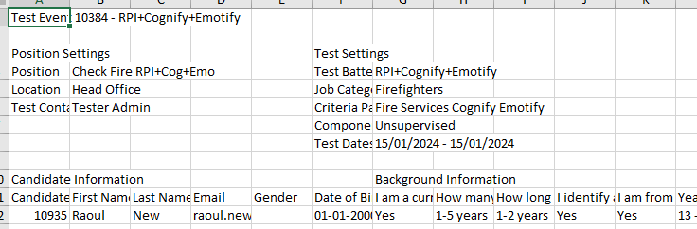

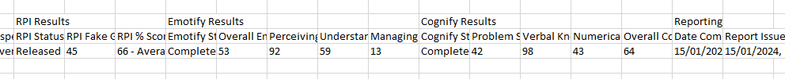

**Export MSA Results** is only visible & available to Master System Administrators. This will download the same spreadsheet as above, but will also include all responses to all questions completed for the first time. (If candidate releases results, individual responses will be blank).

## Comprehensive Report

The RPI Comprehensive report has been engineered & modified over the last 30 years into the below format, to make the assessment results as relevant as possible.

The Report takes all the data from the assessment and utilises tables to make this meaningful. WE will break down each section of the report as follows:

## Comprehensive Report – Cover page

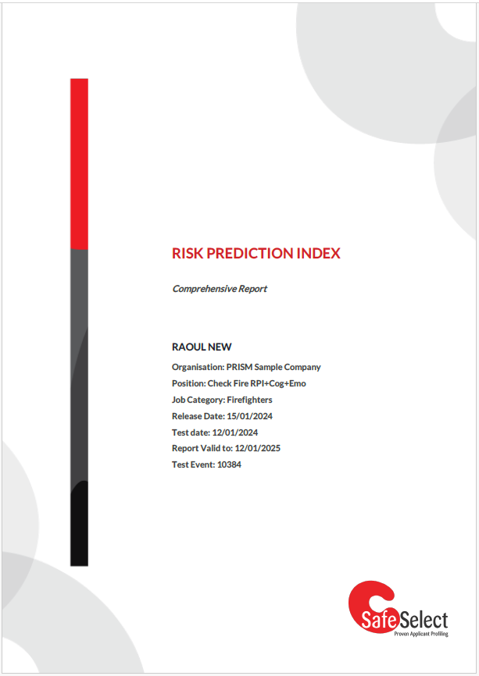The cover page will contain a summary of the report information as pictured, being:

• First & Last name

• Organisation

• Position (as entered in test setup)

• Job Category (of the RPI only)

• Release Date (only appears if Report was released to show date released)

• Test completed date (if released, this is the original date test 1st completed)

• Report valid to (12 months from Test Date)

• Test Event number

## Comprehensive Selection Report – Candidate Background Information

The Guide to PRISM Workflow covers how this works in detail, and will display all the relevant Candidate Background Information that the candidate selected, as the first section on the second page of the Comprehensive Report.

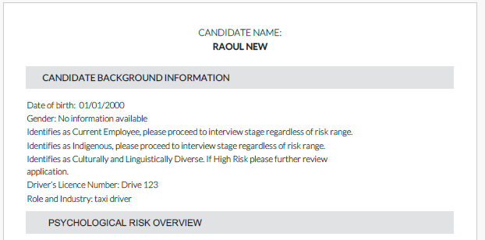

## Comprehensive Selection Report – Psychological Risk Overview

This section is a summary of the RPI and Cognify scores (if applicable). Summarises the Risk Range and Recommendation. 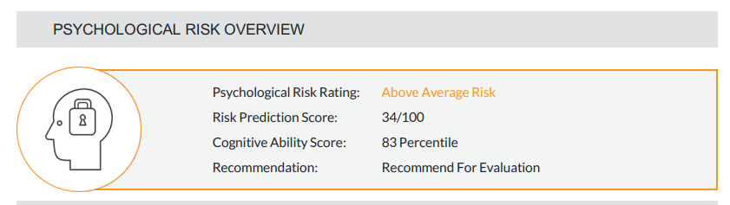

### Psychological Risk Rating

The Psychological Risk Rating statement is derived from the candidate score across the RPI and/or the Cognify assessment & works from the top down, to display the corresponding statement, depending on the candidates’ Cognify score, Fake Good score, Careless Responding Score, or overall RPI Score.

In the above image, the candidate had a Cognify score above 12, Fake Good score above -4, Careless Responding above -4 & an RPI percentile of 34, so qualified for an Above Average Risk description.

|  |  |
| --- | --- |
| *If Cognify Percentile is included &: | Psychological Risk Rating is: |
| 12 or less | High Risk – Low Cognitive Ability |
| If Fake Good applies: | Psychological Risk Rating is: |
| Fake Good STEN is -4 | Invalid High Fake Good |
| If High Careless Responding applies: | Psychological Risk Rating is: |
| Careless Responding STEN is -4 | Invalid Low Consistency |
| If RPI Percentile is: | Psychological Risk Rating is: |
| RPI Percentiles of 0 to 24 | High Risk |
| RPI Percentiles of 25 to 39 | Above Average Risk |
| RPI Percentiles of 40 to 74 | Average Risk |
| RPI Percentiles of 75 to 89 | Below Average Risk |
| RPI Percentiles of 90 to 100 | Low Risk |

### Risk Prediction Score

The Risk prediction Score is simply the Overall RPI Score as detailed earlier.

### Cognitive Ability Score

If Cognify is included in this assessment, then this is simply the overall Cognify score for this scale.

### Recommendation

There are the following recommendation statements that will appear in this hierarchy. If the top statement is not applicable, then the next is reviewed & so on, until there is a match:

|  |  |
| --- | --- |
| If the Cognify Score is used & 12 or less | High Risk: Low Cognitive Ability |
| If the Fake Good STEN is -4 | Invalid Profile: High Fake Good |
| If the Careless Responding STEN is -4 | Invalid Profile: Low Consistency |
| If the RPI score is 26 or more | Recommend For Evaluation |
| If the RPI score is 25 or less | High Risk |
| If the RPI score is 25 or less, and/or the Cognify Score is 12 or less and  • Candidate identified as current employee, or  • Candidate identified as indigenous, or  • Candidate identified as CaLD | Further Consideration Required |

## Prior Assessment Results

This section lists up to the last two results, listed side by side, with the following relevant details: Psychological Risk Rating, Risk Prediction Score, Cognitive Ability Score (if applicable), Job Category (of the RPI) & the Test Date when completed.

If there are no prior assessments, a statement will appear “No prior assessment results”

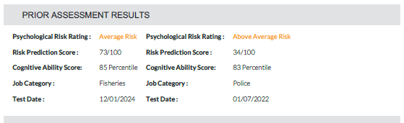

OR:

## Assessment Validity

The following Assessment Validity section can be found at  
Teams > PRISM UAT > RPI-COGNIFY-ASM > RPI > Report Look and Feel > Candidate Selection Report = Candidate Selection Report Interpretive Statements 18.10.2024

[Candidate Selection Report - Interpretive statements 18.10.2024.xlsx](https://convergeintl.sharepoint.com/:x:/s/PRISMUAT/EQmwmBUuyB5EtXiJi_wGv_QBUH6_-rwB5FBcawI0Q-G0gA?e=DSce2Z)

This populates the Report with appropriate validity statements.

|  |  |  |  |  |
| --- | --- | --- | --- | --- |
| **Validity Scenarios** | | | | |
| **Fake Good** | **Consistency** | **Guardedness** | **Invalid?** | **Message** |
| -4 | - | - | YES | This report is **not valid** for interpretation as the candidate attempted to describe themselves in an overly positive manner to the degree where a valid report cannot be produced. |
| -4 | -4 |  | YES | This report is **not valid** for interpretation as the candidate was extremely inconsistent in their responses and attempted to portray themselves in an overly positive manner. A valid report cannot be produced. |
| - | -4 | - | YES | This report is **not valid** for interpretation as the candidate was extremely inconsistent in their responses to the degree where a valid report cannot be produced. |
| -3/-2 | -3/-2 | -4 | - | This report is valid for interpretation however some caution should be exercised when interpreting the results as the candidate has been somewhat inconsistent in their responses, has described themselves in an overly positive manner and has been extremely guarded. |
| -3/-2 | -1/ Average | -4 | - | This report is valid for interpretation. The candidate was reasonably consistent in their responses, however some caution is to be exercised when interpreting results as they tended to describe themselves in an overly positive manner and be extremely guarded. |
| -1/ Average | -3/-2 | -4 | - | This report is valid for interpretation. The candidate was reasonably honest in their responses, however some caution is to be exercised when interpreting results as they tended to be extremely guarded and somewhat inconsistent in their responses. |
| -1/ Average | -1/ Average | -4 | - | This report is valid for interpretation. The candidate was reasonably consistent and honest in their responses, however some caution should be exercised when interpreting results as the candidate was extremely guarded. |
| -3/-2 | -3/-2 | -3/-2 | - | This report is valid for interpretation, however some caution should be exercised when interpreting results as the candidate was somewhat inconsistent and guarded in their responses, and tended to describe themselves in an overly positive manner. |
| -3/-2 | -3/-2 | -1/ Average | - | This report is valid for interpretation. The candidate was reasonably open in their responses, however was somewhat inconsistent and tended to describe themselves in an overly positive manner. |
| -3/-2 | -1/ Average | -3/-2 | - | This report is valid for interpretation. The candidate was reasonably consistent in their responses, however some caution should be exercised when interpreting results as the candidate was somewhat guarded and tended to describe themselves in an overly positive manner. |
| -3/-2 | -1/ Average | -1/ Average | - | This report is valid for interpretation as the candidate was reasonably consistent and open in their responses. However some caution should be exercised when interpreting results as the candidate had a tendency to portray themselves in an overly positive manner. |
| -1/ Average | -3/-2 | -3/-2 | - | This report is valid for interpretation as the candidate was reasonably honest in their responses. However some caution should be exercised when interpreting results as the candidate was somewhat guarded and inconsistent in their responses. |
| -1/ Average | -3/-2 | -1/ Average | - | This report is valid for interpretation as the candidate was reasonably open and honest in their responses. However some caution should be exercised when interpreting the results as the candidate was somewhat inconsistent in their responses. |
| -1/ Average | -1/ Average | -3/-2 | - | This report is valid for interpretation as the candidate was reasonably honest and consistent in their responses. However some caution should be exercised when interpreting the results as the candidate was somewhat guarded in their responses. |
| -1/Average | -1/Average | -1/Average | - | This report is valid for interpretation as the candidate was reasonably open, honest and consistent in their responses. |

### Assessment Validity – what to do when Invalid

When the assessment is invalid, the appropriate statement will appear, but another detail will occur. All report information still displays, but a warning header is added to each page and next to each factor on the table.

The header will either state Invalid Profile: High Fake Good or Invalid Profile: Low Consistency.



## About This Report

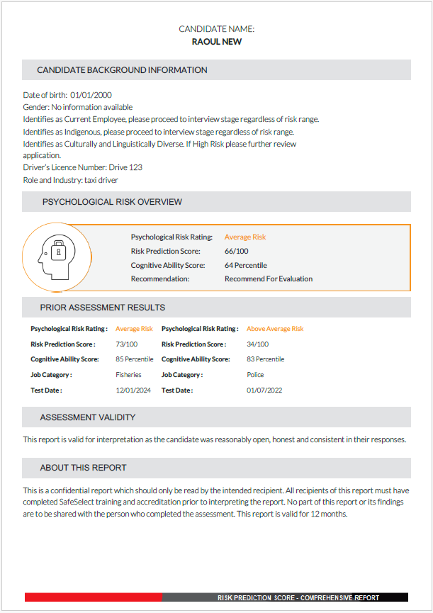The last section of the page, About This Report, is a default statement that appears on every report with no alteration:

This is a confidential report which should only be read by the intended recipient. All recipients of this report must have completed SafeSelect training and accreditation prior to interpreting the report. No part of this report or its findings are to be shared with the person who completed the assessment. This report is valid for 12 months.

## Psychological Risk Profile - Table of Scales

Pages 3 & 4 of the RPI report displays the Psychological Risk Profile of each scale as a table.  
On the table of scales, all scales are grouped by Factor and their display STEN used to display the value of the scale from -4 to +4.   
At the top of each page is the title and candidate name.

Factors will display in this sequential order: Approach to Testing, Ability to Learn and Understand (if used), Working with Others, Work Style, Psychological Adjustment, Self Control.

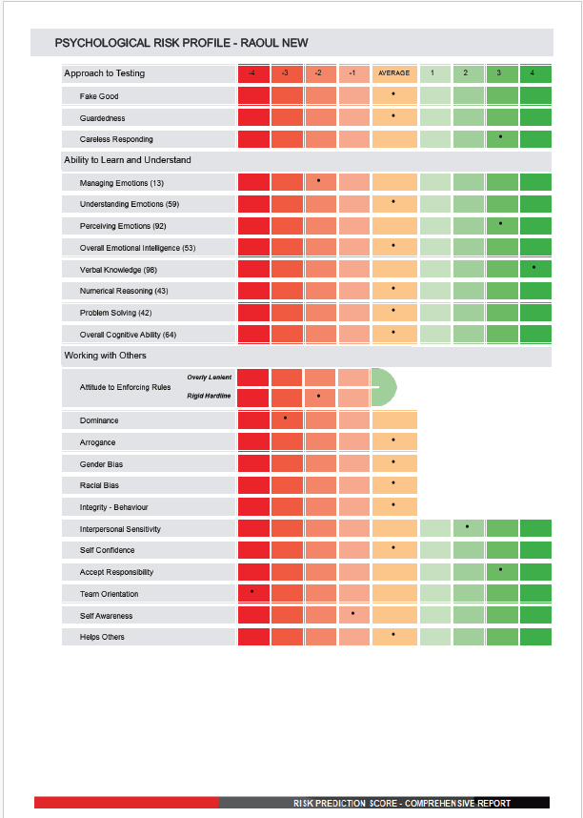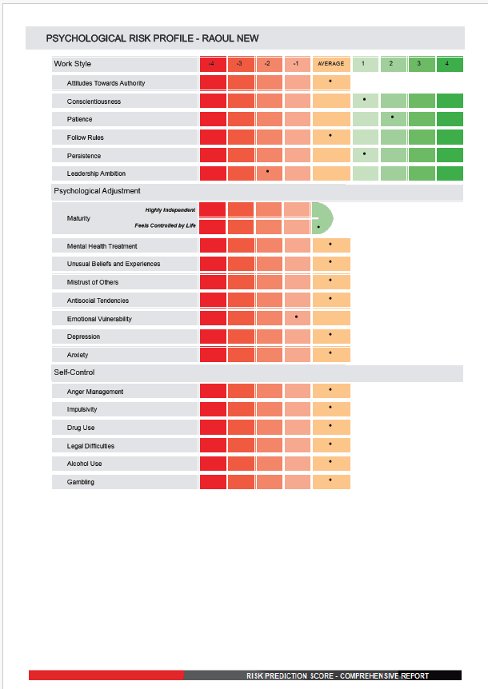

### Approach to Testing

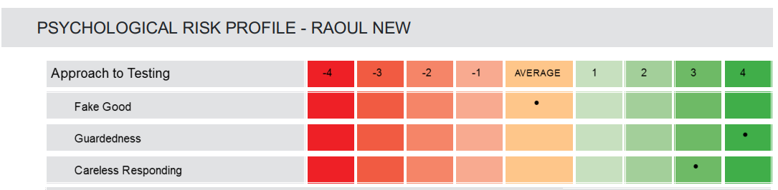

### Ability to Learn and Understand

Displays firstly, Emotify sub-scores then overall score, then secondly Cognify sub-scores then overall score if both are used, otherwise just the assessment results that were taken. If the Cognify and/or Emotify assessment were not taken, this section does not display.

### Working with Others

Displays in the below sequence:

### Work Style

This starts off the second page. Displays in the below sequence:

### Psychological Adjustment

Displays in the below sequence:

### Self-Control

Displays in the below sequence:

## Comprehensive Report – Risk Profile Interpretation pages

Following on from the Psychological Risk Profile pages are the Risk Profile Interpretation statements that give descriptive statements for each scale, depending on their STEN score.

The layout groups scales under each Factor, being Ability to Learn and Understand, Working with Others, Work Style, Psychological Adjustment & Self-Control.   
Approach to Testing does not appear here as the relevant statements display on the 2nd page under Assessment Validity.

### Displaying Scales under each Factor

Each Scale has a value on the Psychological Risk Profile table, from -4 to +4.  
That value will determine if a corresponding statement will be displayed as

• Potential High Risks,

• Potential Average Risks OR

• Potential Low Risks/Strengths

The Interpretive Statements, with values for each scale can be found at  
Teams > PRISM UAT > RPI-COGNIFY-ASM > RPI > Report Look and Feel > Candidate Selection Report = Candidate Selection Report Interpretive Statements 18.10.2024

[Candidate Selection Report – Interpretive statements 18.10.2024.xlsx](https://convergeintl.sharepoint.com/:x:/s/PRISMUAT/EQmwmBUuyB5EtXiJi_wGv_QBUH6_-rwB5FBcawI0Q-G0gA?e=DSce2Z)

For example, in the below screenshot the candidate had a STEN score of -3 or -4 for the scale Leadership Ambition & a STEN score of +1 or +2 for the scale Persistence.

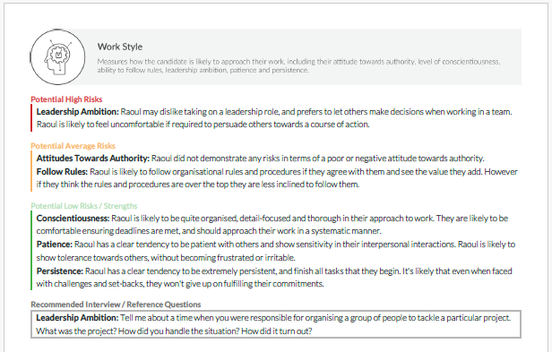

### Scoring Normal Scales

For the report, each scale, except Maturity & Attitude to Enforcing Rules (horseshoe scale), is split into

• Potential High Risks -1&-2 (slight risk) and -3&-4 (significant risk),

• Potential Average Risks 0 (Average) and

• Potential Low Risks/Strengths +1 & +2 (slight strength) and +3 & +4 (significant strength)

### Scoring Horseshoe Scales

For the report, each horseshoe scale, being Maturity & Attitude to Enforcing Rules, is split into

• Potential High Risks -2 (slight risk) and -3&-4 (significant risk),

• Potential Average Risks -1 (slight risk) and

• Potential Low Risks/Strengths 0 (Average)

### Recommended Interview Questions

Underneath the Risks & Strengths is a separate box labelled Recommended Interview/Reference Questions. Where any scale scores -2, -3 or -4, an Interview question is inserted for that scale.

Where multiple scales are identified, they all list within the same box.

The Interview Questions can be found at   
Teams > PRISM UAT > RPI-COGNIFY-ASM > RPI > Report Look and Feel > Candidate Selection Report = API Interview Reference Questions

<https://convergeintl.sharepoint.com/:x:/s/PRISMUAT/EZGSAuIetPFDm41NPrkeiAIBpJuU4FImloZQGtplUBCyIQ?e=bu0q29>

### Recommended Reference Questions

The Reference Questions do not appear as at 18.01.2024. This is an upcoming addition to the report.  
The existing box labelled Recommended Interview/Reference Questions will be re-labelled Recommended Interview Questions.  
Below this will appear a separate box labelled Recommended Reference Questions

Where any scale scores -2, -3 or -4, a Reference question is inserted for that scale.

Where multiple scales are identified, they all list within the same box.

The Reference Questions can be found at   
Teams > PRISM UAT > RPI-COGNIFY-ASM > RPI > Report Look and Feel > Candidate Selection Report = API Interview Reference Questions

<https://convergeintl.sharepoint.com/:x:/s/PRISMUAT/EZGSAuIetPFDm41NPrkeiAIBpJuU4FImloZQGtplUBCyIQ?e=bu0q29>

# Comprehensive Report – Candidate Background Information

Follow on from the Risk Profile Interpretation pages is the Candidate Background Information.

Note, the title currently says **Candidate Background Information** and should say **Supplementary Items for Interview.** At this time, it is not going to change.

This lists critically endorsed items (in bold) and potentially revealing items (plain text) by the candidate.

The page is separated into

• factors, then

• scales, then

• critically answered questions (in bold), then

• then potentially revealing questions (in plain text)

These critical and revealing questions are referenced in the four assessment Scales , LOC, COS, OPA & SAFE.

The questions, from all scales, have

• a column entry for Answer “x” Revealing, TRUE/FALSE, and

• Answer “x” Critical, TRUE/FALSE

This obviously answers whether the answer is revealing or not, or critical or not.



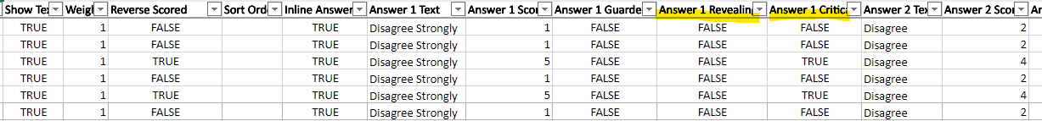

If the answer is critical and true, the question appears on the Supplementary Items for Interview in bold, under the relevant scale.

If the answer is revealing and true, the question appears on the Supplementary Items for Interview in plain text, under the relevant scale.

If the answer was neither, it will not appear here.

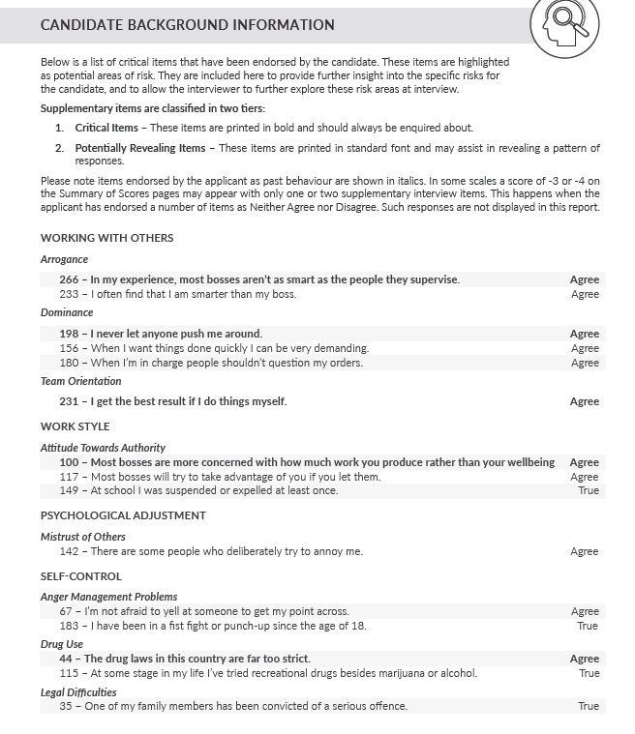

**FACTOR**  
*Scale*  
**Critical Item**  
Potentially   
 Revealing Item

# Comprehensive Report – About this Report

This is a standard page that appears at the end of every report, with two notable differences.

For Reports that do not have Cognify and/or Emotify, this descriptive paragraph is left out.   
In the Measuring Potential Psychological Risk paragraph, the jurisdiction is inserted into the sentence:

“Risk ranges are measured on a bell curve, with average risk corresponding to the average risk rating for all [Job Category] applicants who have been assessed with SafeSelect.”

# Future Development plans

At a much later stage, a separate report is being considered that can safely be issued to the candidate. This will take the details from the RPI, but selectively provide feedback that can safely be provided without causing harm to the candidate.

# Candidate Feedback Report – front page (to be built)

PLEASE NOTE THE FEEEDBACK REPORT WILL BE IN PRISM V2

The RPI Feedback Report page will have the same look and feel as the Selection report. There are some differences in the information that is displayed as shown below.

Front page as shown below is slightly different from front page of selection report.

Please note the example below is for the ASM – this is to give you the look and feel of the report.

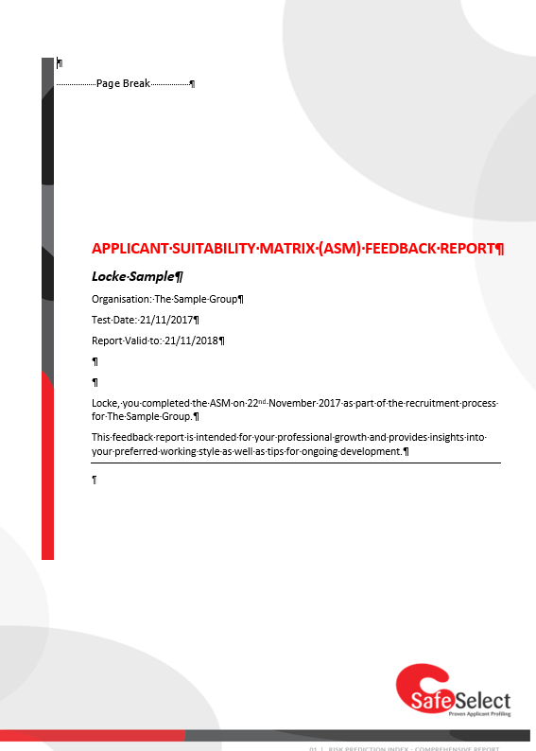

This should say Risk Assessment Feedback Report

# Candidate Feedback Report – Interpretation pages

There is no summary profile included in the Feedback report, just the interpretation pages as shown below

(please change the heading to Assessment Feedback)

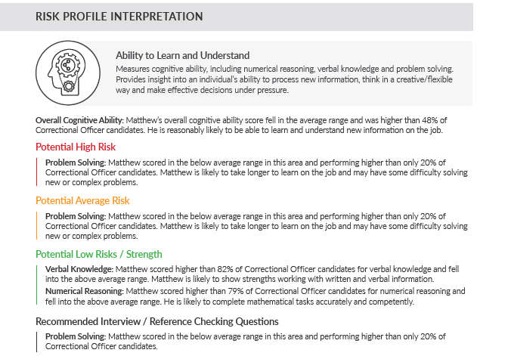

• Please use the same headings and icons and definitions as per the Selection report i.e. Ability to Learn and Understand, Emotional Intelligence, Working with Others, Work Style and Emotional Control (this one is different – we will not be including Psychological Adjustment and Self Control).

• For Ability to Learn and Understand and Emotional Intelligence please include one statement from this worksheet <http://tiny.cc/qf1ajz> depending on the candidate’s score.

**Working with Others**

Please break this down into three subsections

1. Interpersonal Sensitivity

2. Self Awareness

3. Leadership

Please see the above worksheet for the statements that should be included under each subheading.

**Work Style**

Please break this down into two subsections

1. Organisational Skills

2. Rule Following

Please see the above worksheet for the statements that should be included under each subheading.

**Emotional Control**

Please break this down into two subsections

1. Resilience

2. Maladaptive behaviours (but only if there are scores of 1-,-2,-3 or -4 in any of the subscales listed in the spreadsheet. If the scores on these scales are average do not include this subsection

Please see the above worksheet for the statements that should be included under each subheading.

For the final page of the report please include the About this Report page from the Selection report.

# Client Experience

1. The client will log in to PRISM as per normal

2. The client will choose the RPI test for testing purposes

3. The client will choose the jurisdiction

4. The client will choose the start-end dates for the test event

5. The client will add candidates for Test Now or Test Setup

a. If paying by credit, the client will use the credit at this time

b. If they have a subscription, unlimited testing is included

6. The client will see (via their portal access) the candidates who have/have not completed

a. If paying by credit, the client will be refunded the credit for any candidate who does not complete

7. The client will view summary version of the results

8. The client will choose which candidates they want the Comprehensive report for

9. The client can access this report any time now, and in the future, with an active account. A plan will have to be made for clients without an active account, ie a fee or otherwise to retrieve reports, and then pass on to trained staff.

# Candidate Experience

1. The candidate will either test now, or receive an email invite to test unsupervised

2. The candidate will sign in to PRISM

3. The candidate will see listed the tests to complete, and click to proceed

4. The candidate will agree to the informed consent

5. The candidate will start untimed testing

6. The candidate may partially complete and be reminded to finish

7. The candidate will finish and return to the PRISM home page

8. Their home page will update to show RPI in their Completed Tests list

Ideally, their records should be kept indefinitely and flagged as already completed, should they be prompted to re-test within 12 months.

If asked to re-test within 12 months, the PRISM home page should show the new invite to test added to the Completed section, so candidate knows they have done this. (If this was different jurisdiction, test would be re-scored for jurisdiction automatically).